Jordan Alyssa Landes-Brenman
CEO & Fashion Publicist – Haute House PR & Marketing
Founder/Creative Director – Haute Blue Web
On-Air Fashion Talent – eHow
Personal Style Blogger - Haute House Flower
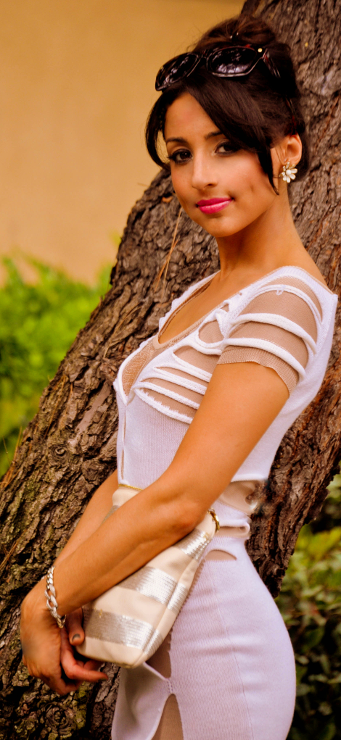
A lifelong lover of all things fashion-related, Haute House PR & Marketing’s CEO and Founder; Jordan Landes-Brenman (31) has had a comprehensive and successful career representing clients in every facet of the fashion industry for the past decade. As founder of her agency, Haute House PR & Marketing, LLC since its launch five years ago (July 2009), Jordan has represented a wide range of brands including; women’s luxury and contemporary apparel, accessories and jewelry, beauty, online fashion retailers, retail locations and beauty salons. Her background includes; studies in Paris, trunk shows with Diane Von Furstenberg and Chanel, event production and PR for Mercedes-Benz IMG Fashion Week, Prêt à Porter Paris, and years as Director of Product Placement & Publicity in Hollywood, CA at another bi-coastal fashion PR agency.

At Haute House PR, Jordan consistently garners her clients editorial placements in hundreds of media outlets including; Glamour, Marie Claire, InStyle, Lucky, WWD, ELLE, Cosmopolitan, US Weekly, NYLON, and People Stylewatch Magazine just to name a few. She also regularly places her client’s brands on A-list celebrities including; Heidi Klum, Taylor Swift, Gisele Bundchen, Nicole Richie, Rachel Bilson, Halle Berry, Selena Gomez, Jessica Alba, Kim Kardashian, Blake Lively, and many more. No matter what the project, Jordan brings to the table a penchant for creating new concepts to achieve world-wide brand promotion, and recognition. Her commitment to anticipating the needs of both clients, media, and stylists alike have set her apart from other publicists in her field. Through her extensive career launching emerging brands to become household names, Jordan brings with her a passion for the industry, innovative, out-of-the-box marketing concepts, as well as an unparalleled attention to detail, which she implements daily into every element of Haute House PR.

Jordan continues to broaden her horizons serving as Haute House PR’s official on-camera style/trend forecasting expert. In June 2013, Jordan landed her own video fashion expert series, “Haute How-To’s” with eHow.com. Over the years, she has appeared as PR and Trend Expert in a plethora of various celebrity and fashion segments on major TV networks such as; Extra, E! News, Kiss The Runway, TV Guide, as well as in print publications including; The LA Business Journal, OK! Magazine, San Fernando Valley Business Journal, Ventura Boulevard Magazine, and Saturday Night Magazine. She has also been featured on various other online media outlets including; SimplyStylist.com, The Daily Media, Channel 9 Network’s “Shoe Hoarders” web series with Nine West, xoTheBlush.com, and is an online style columnist for Ventura Blvd Magazine. Additionally, she serves as an event correspondent for StyleMusicTV.com, and regularly appears as a PR expert on podcasts for various entrepreneur websites including; TinShingle.com, and BlogTalkRadio.com.

In October 2013, Jordan expanded her reach beyond the fashion industry with the launch of sister company, Haute Blue Web. Available to individuals and companies in every industry, Haute Blue Web specializes in SEO, social media, graphic design, e-commerce, and website services. Jordan will be launching a personal style blog, Haute House Flower in the Fall of 2014, which will create a streamlined platform to house all of her fashion PR expertise, on-air, and fashion-industry projects.

Jordan Landes-Brenman’s eHow.com “Haute How-To’s” Video Links:

Series I: “Fashion Styling & Storage”, Publisher: www.eHow.com; Publish Date: July 25, 2013
http://www.ehow.com/video_12301042_ideas-want-dress-like-cher.html
http://www.ehow.com/video_12301013_careers-fashion-promotions.html
http://www.ehow.com/video_12301014_storage-ideas-shoes-purses.html
http://www.ehow.com/video_12301017_storage-ideas-rings.html
http://www.ehow.com/video_12301019_purse-ideas-girls.html
http://www.ehow.com/video_12301021_kate-middleton-fashion-ideas.html
http://www.ehow.com/video_12301022_dress-winter-fashion-internship.html
http://www.ehow.com/video_12301025_need-fashion-week.html
http://www.ehow.com/video_12301027_cute-ideas-dress-like-hipster.html
http://www.ehow.com/video_12301041_different-ideas-tie-scarf.html

Series II: “Great Fashion Advice”, Publisher: www.eHow.com; Publish Date: July 31, 2013
http://www.ehow.com/video_12302544_tell-authentic-chanel-jacket.html
http://www.ehow.com/video_12302545_top-highend-handbags.html
http://www.ehow.com/video_12302546_tie-chanel-scarf.html
http://www.ehow.com/video_12302547_clothing-rental-websites-work.html
http://www.ehow.com/video_12302548_dress-cool-gym.html
http://www.ehow.com/video_12302549_dress-hot-gym.html
http://www.ehow.com/video_12302550_fashion-during-70s.html
http://www.ehow.com/video_12302552_dress-like-stepford-wife.html
http://www.ehow.com/video_12302551_dress-man-work.html
http://www.ehow.com/video_12302553_actresses-impact-fashion.html

Series III: “Great Fashion Tips For Men”, Publisher: www.eHow.com; Publish Date: September 10, 2013
http://www.ehow.com/video_12312608_hip-size.html
http://www.ehow.com/video_12312609_color-tie-blue-suit-interview.html
http://www.ehow.com/video_12312610_purple-tie-attire-mean.html
http://www.ehow.com/video_12312611_color-tie-white-shirt-gray-suit.html
http://www.ehow.com/video_12312612_top-fashion-2010.html
http://www.ehow.com/video_12312613_use-collar-stays.html
http://www.ehow.com/video_12312614_average-price-mens-suit.html
http://www.ehow.com/video_12312615_elbow-patches-sweaters-called.html
http://www.ehow.com/video_12312616_tie-clip-look-like.html
http://www.ehow.com/video_12312617_use-tie-clips.html

Series IV: “Haute Fashion”, Publisher: www.eHow.com; Publish Date: January 11, 2013
http://www.ehow.com/video_12328140_good-way-polish-tiffany-bracelet.html
http://www.ehow.com/video_12328132_authenticate-chanel-flats.html
http://www.ehow.com/video_12328135_prepare-yourself-dress-alteration.html
http://www.ehow.com/video_12328141_style-leopard-scarf.html
http://www.ehow.com/video_12328138_temporarily-hem-jeans.html
http://www.ehow.com/video_12328137_use-instead-fanny-pack.html
http://www.ehow.com/video_12328134_work-catsuit.html
http://www.ehow.com/video_12328133_womens-shirts-sized.html
http://www.ehow.com/video_12328136_goes-sequin-slip-dress.html
http://www.ehow.com/video_12328139_kind-jacket-goes-sequined-dress.html

Series V: “UGG Boots”, Publisher: www.eHow.com; Publish Date: April 9, 2014
http://www.ehow.com/video_12339266_tell-genuine-ugg-tags.html
http://www.ehow.com/video_12339265_stop-uggs-turning-feet-black.html
http://www.ehow.com/video_12339267_safe-ways-waterproof-ugg-boots.html
http://www.ehow.com/video_12339268_apply-ugg-conditioner-whole-boot.html
http://www.ehow.com/video_12339269_right-fit-ugg-boots.html
http://www.ehow.com/video_12339270_material-soles-ugg-boots-made-of.html
http://www.ehow.com/video_12339271_can-put-ugg-boots-protect-them.html
http://www.ehow.com/video_12339272_materials-used-making-ugg-boots.html
http://www.ehow.com/video_12339273_parts-ugg-boots-arent-waterproof.html
http://www.ehow.com/video_12339274_spot-fake-ugg.html
Jordan Landes-Brenman featured in OK! Magazine as a Fashion PR Expert & On-Air Personality – August 2014

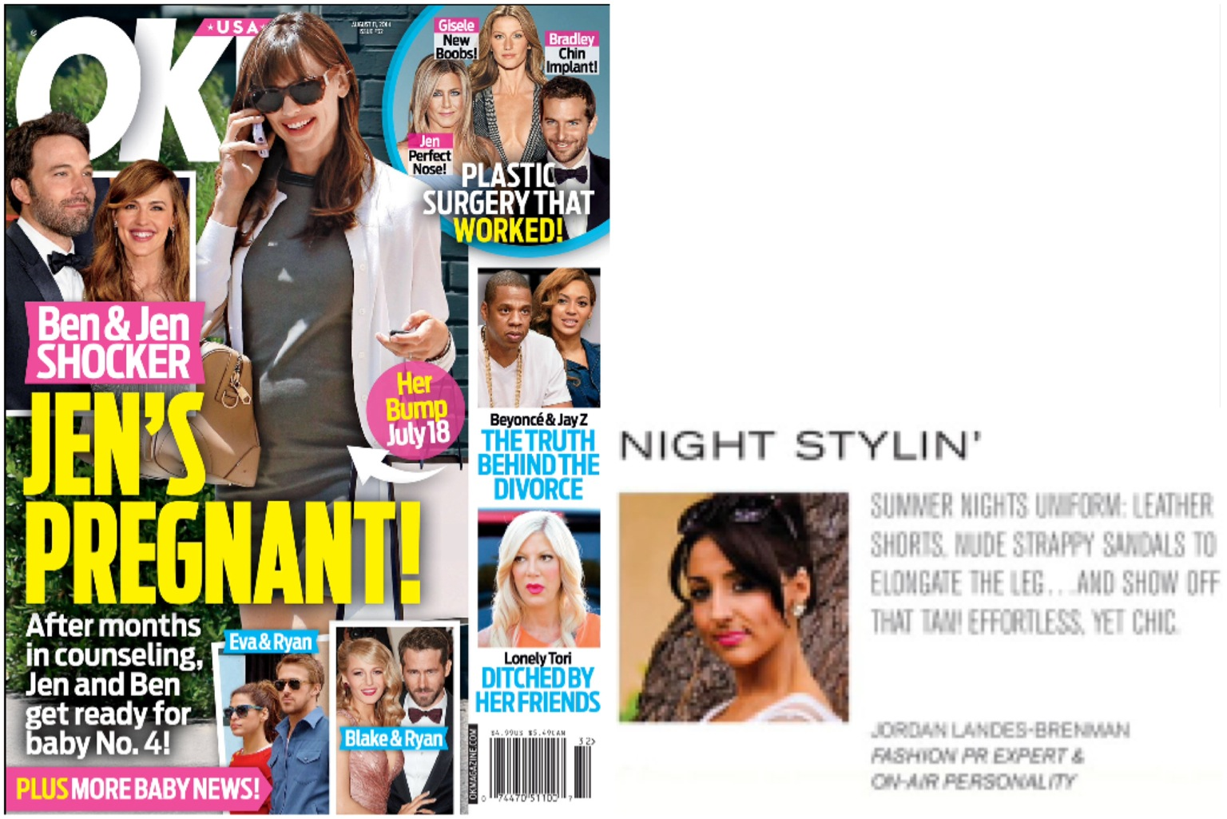

“Haute House PR DJ's the Monday Motivation Mix Comeback Session”-by Sabina Ptacin for TinShingle.com
http://www.tinshingle.com/blog/haute-house-pr-djs-monday-motivation-mix-comeback-session
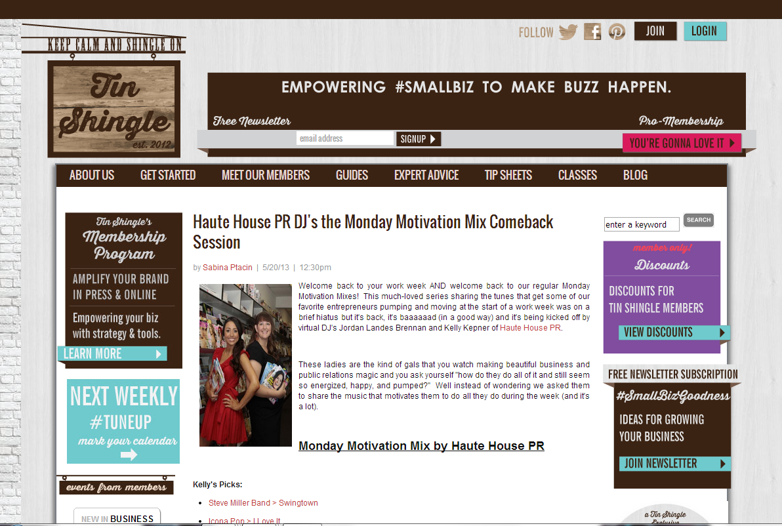

“[PR]: How to Host a Press (Editor) Preview: Proven Strategies for Success”-By Jordan Landes-Brenman, Contributor for TinShingle.Com
http://www.tinshingle.com/how-host-editor-preview-proven-strategies-success
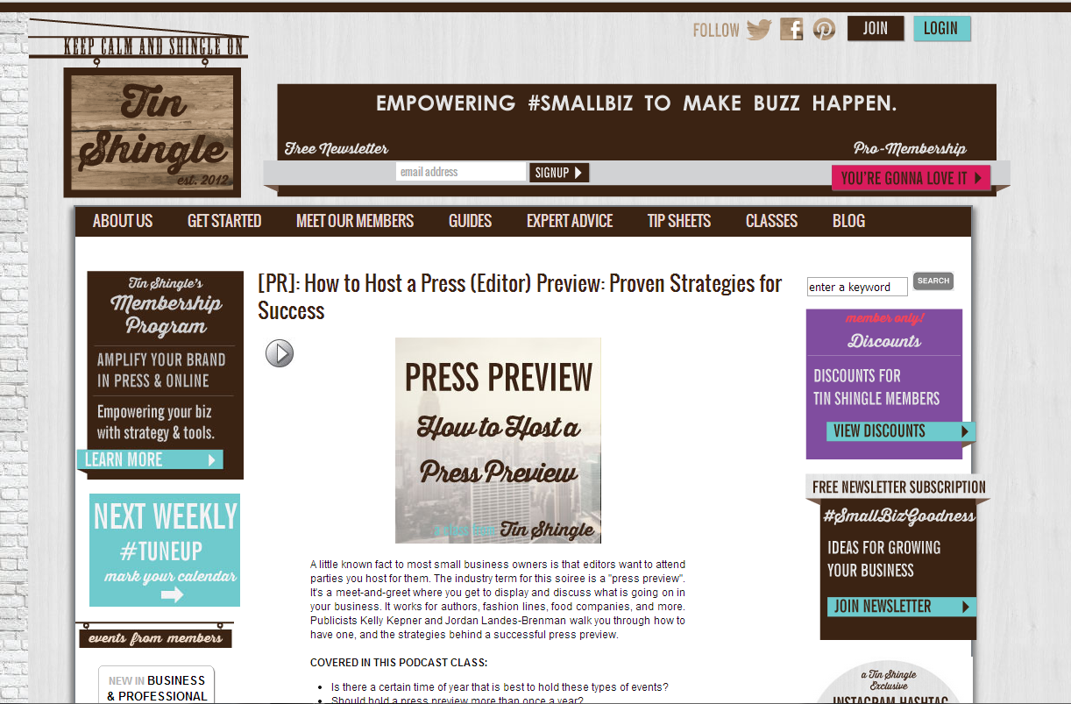
“What is a Regram on Instagram and How Your Business can Use It Strategically”-by Jordan Landes-Brenman, Contributor for TinShingle.com
http://www.tinshingle.com/category/instagram/what-regram-and-how-can-my-business-use-it-strategically
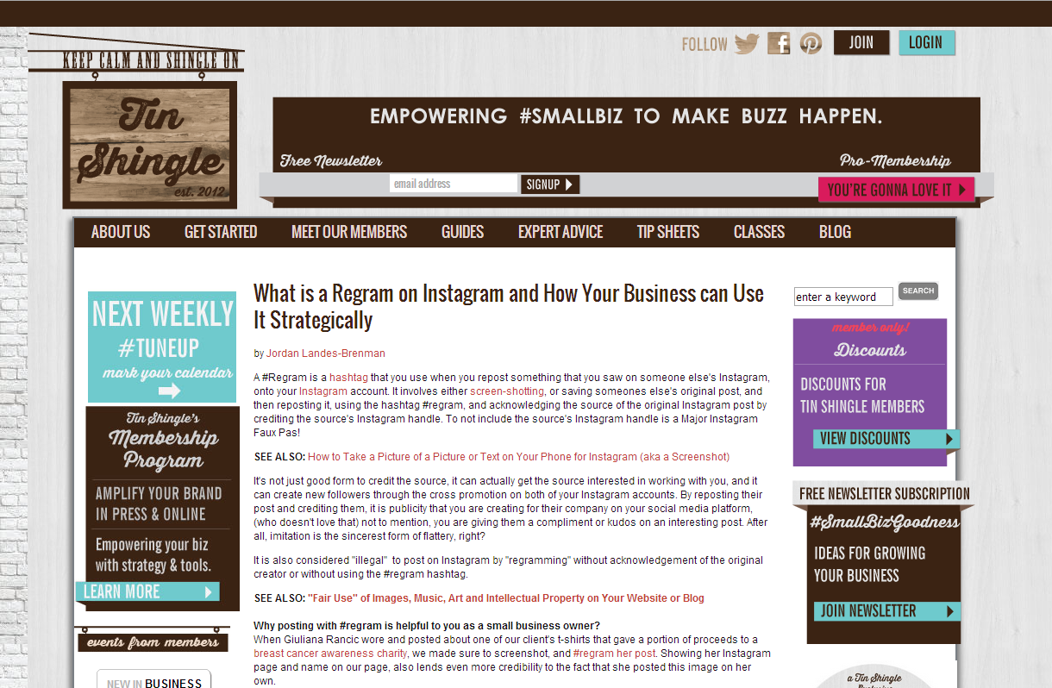

“#SmallBizSpotlight Interview:Kelly Kepner & Jordan Landes-Brenman, founders Haute House PR and Marketing”-by Katie Hellmuth Martin, for TinShingle.com
http://www.tinshingle.com/blog/featured-preneur-kelly-kepner-jordan-landes-brenman
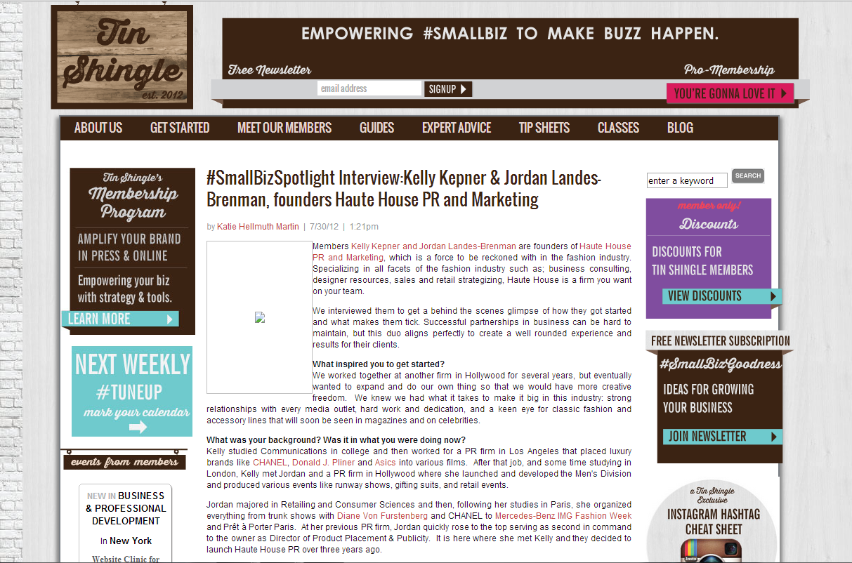
“The Top 10 Do's of How to Get Your Product on Celebrities”-by Jordan Landes-Brenman, contributor for TinShingle.com
http://www.tinshingle.com/category/public-relations/haute-house-pr%E2%80%99s-dos-and-donts-working-celebrities-and-their-handlers-part
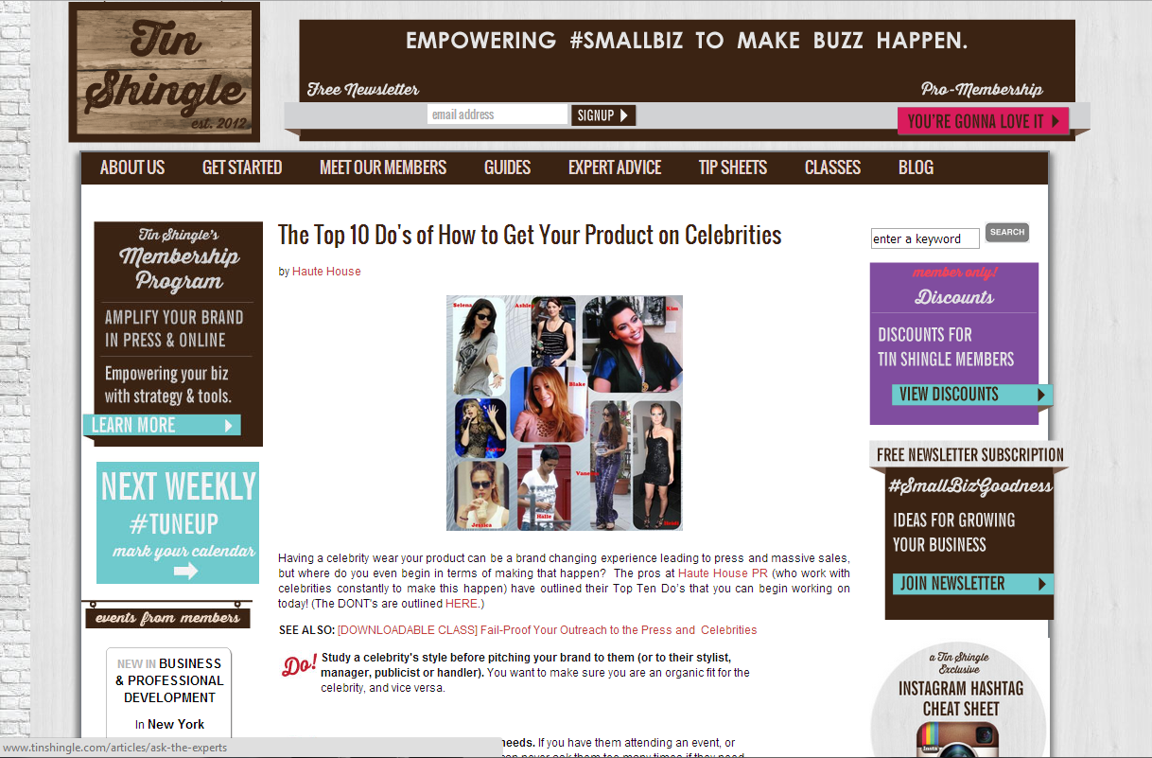

“The Top 10 Don'ts of How to Get Your Product on Celebrities”-by Jordan Landes-Brenman, contributor for TinShingle.com
http://www.tinshingle.com/category/public-relations/haute-house-pr%E2%80%99s-dos-and-donts-working-celebrities-and-their-handlers-pa-0
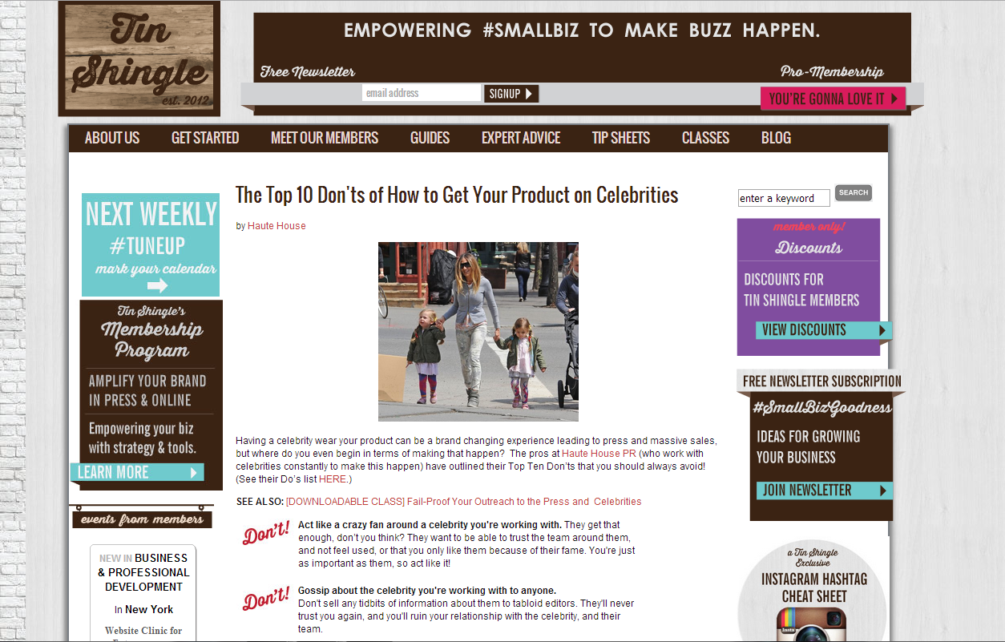
“SNAGGED! How Haute House PR Landed the Better TV Style Segment”-by Sabina Ptacin, for TinShingle.com
http://www.tinshingle.com/blog/snagged-haute-house-pr-answers-pr-lead-scores-tv-press
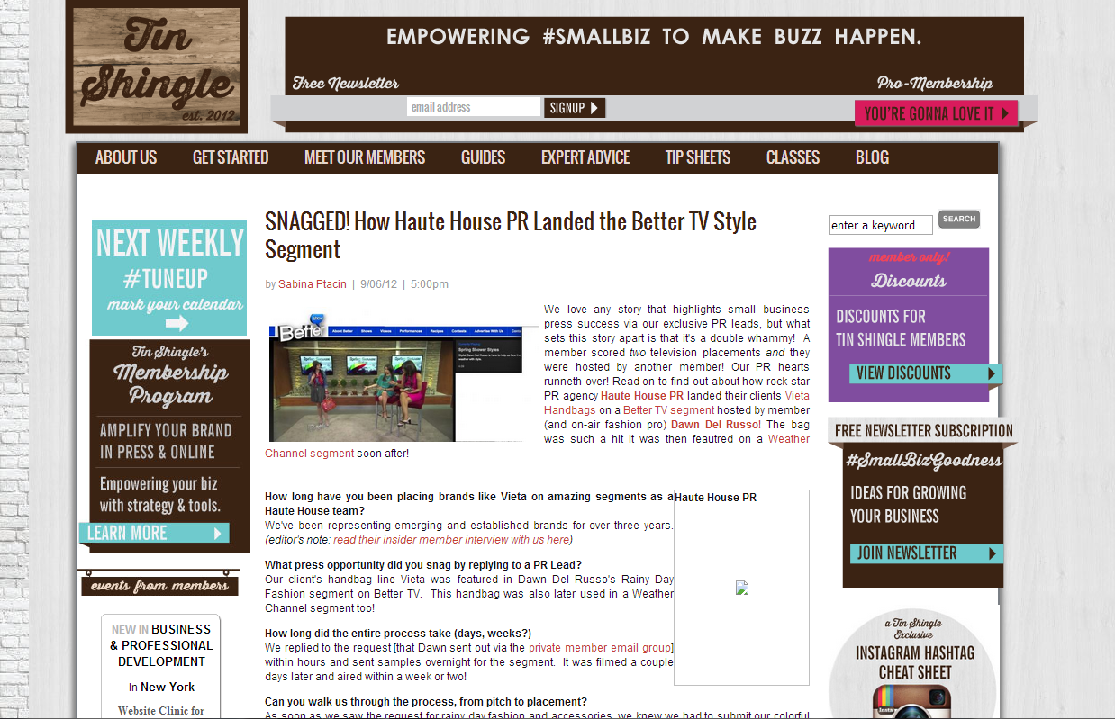

“How to Create an Editor Preview Event to Show Off Your Products with Maximum Results: Your Questions Please!”-by Sabina Ptacin, for TinShingle.com
http://www.tinshingle.com/blog/how-create-editor-preview-your-products-maximum-results-your-questions-please
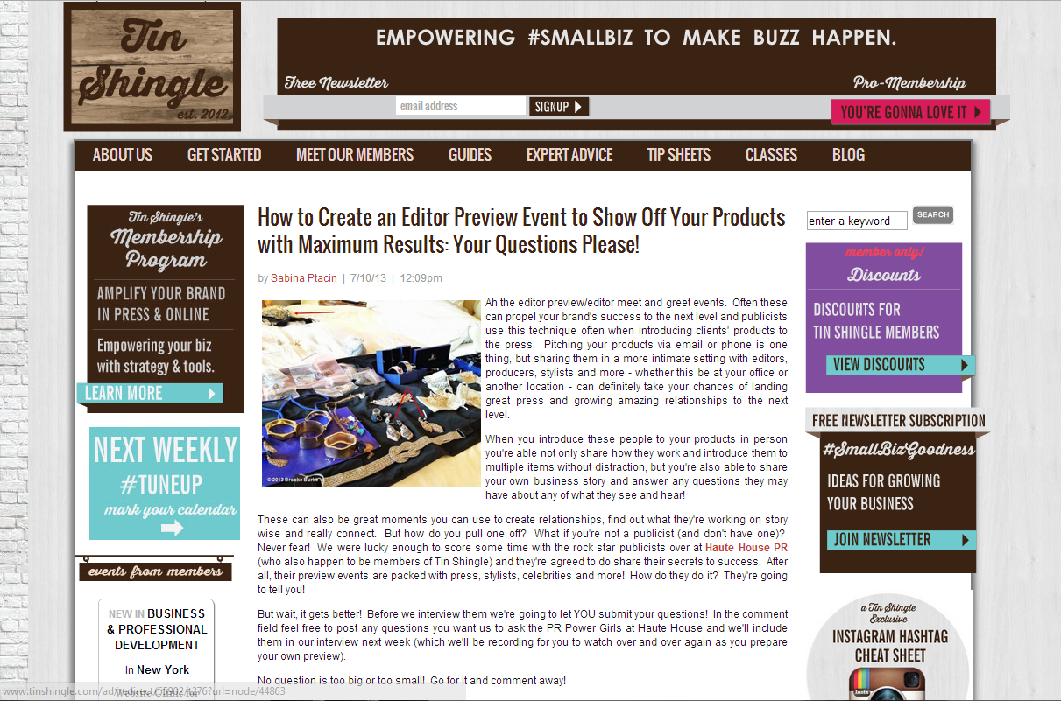
“How to Get Your Product on Celebrities: Expert PR Pros Break it Down”-by Sabina Ptacin, for TinShingle.com
http://www.tinshingle.com/blog/how-get-your-product-or-service-celebrities-expert-pr-pros-break-it-down
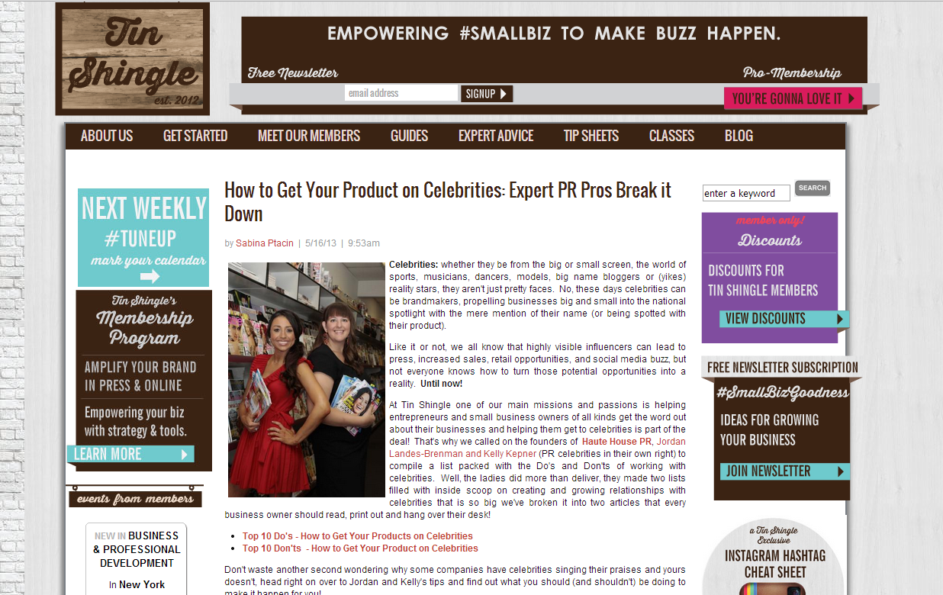

“How To Get Noticed and Gain Traction on Instagram”-by Jordan Landes-Brenman, contributor for TinShingle.com
http://www.tinshingle.com/category/instagram/how-get-noticed-and-gain-traction-instagram-0
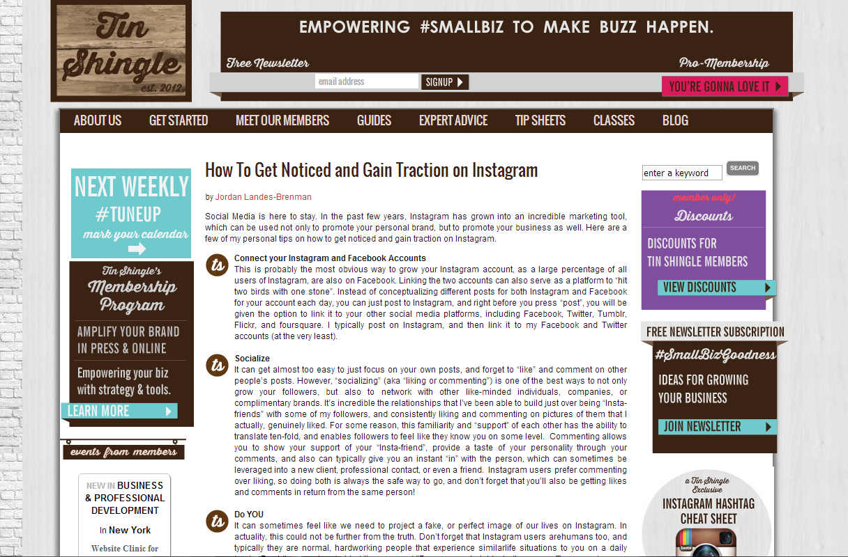
“HAUTE PROFILE: SARAH POLLACK, SIMPLY STYLIST”-by Jordan Landes-Brenman, contributor for OurVenturaBLVD.com
http://www.ourventurablvd.com/Blogs/Haute-in-the-Valley/July-2012/HAUTE-PROFILE-SARAH-POLLACK-SIMPLY-STYLIST/
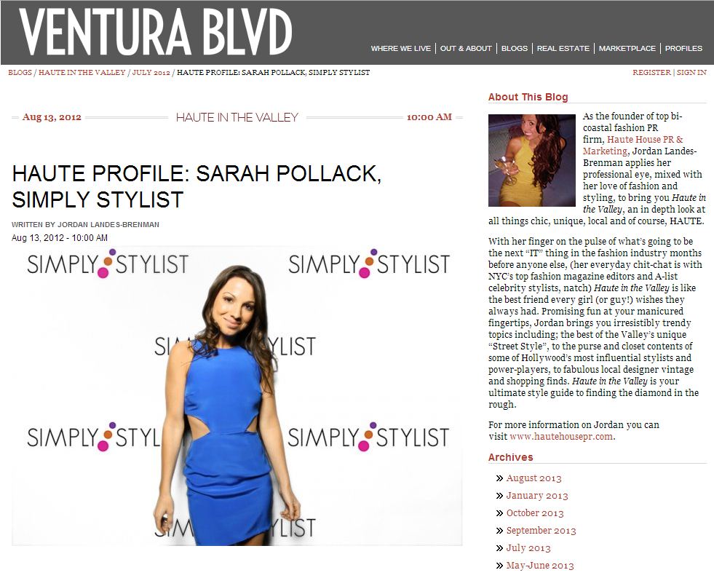

“HAUTE HEADED”-by Jordan Landes-Brenman, contributor for OurVenturaBlvd.com
http://www.ourventurablvd.com/Blogs/Haute-in-the-Valley/June-2012/HAUTE-Headed/
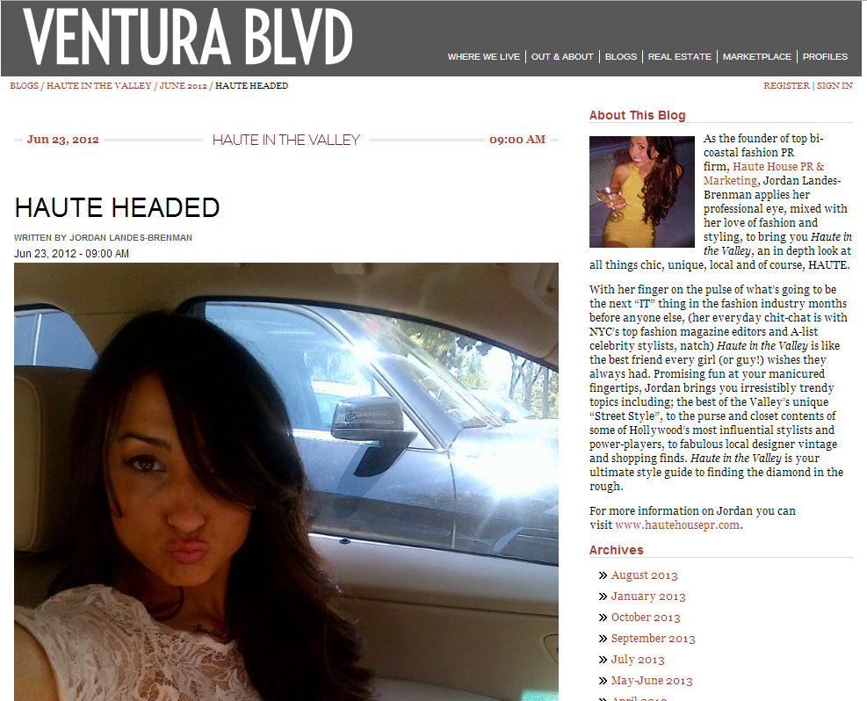
“SKIP TO MY ‘LU”-by Jordan Landes-Brenman, contributor for OurVenturaBlvd.com
http://www.ourventurablvd.com/Blogs/Haute-in-the-Valley/June-2012/Skip-to-My-Lu/
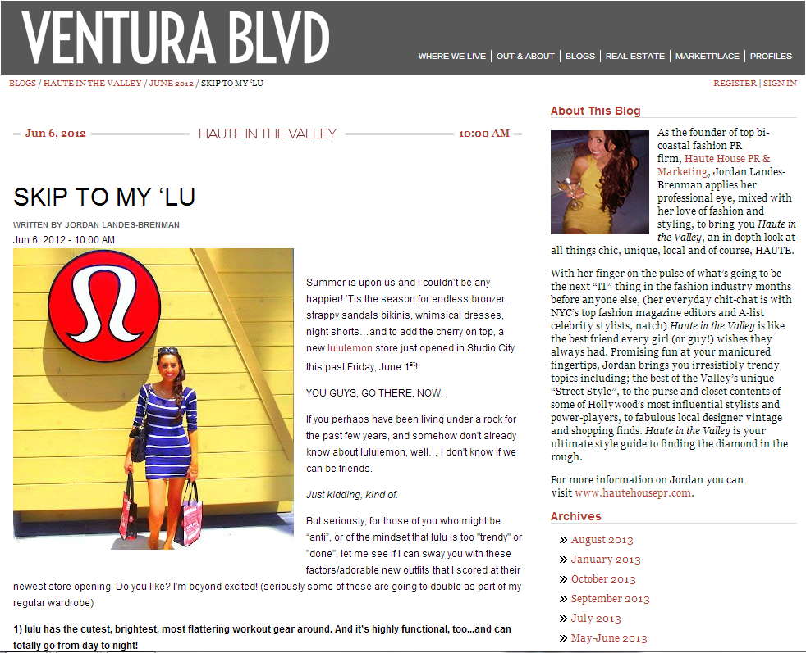

“HAUTE CHILD IN THE CITY”-by Jordan Landes-Brenman, contributor for OurVenturaBlvd.com
http://www.ourventurablvd.com/Blogs/Haute-in-the-Valley/March-2012/HAUTE-Child-In-The-City/
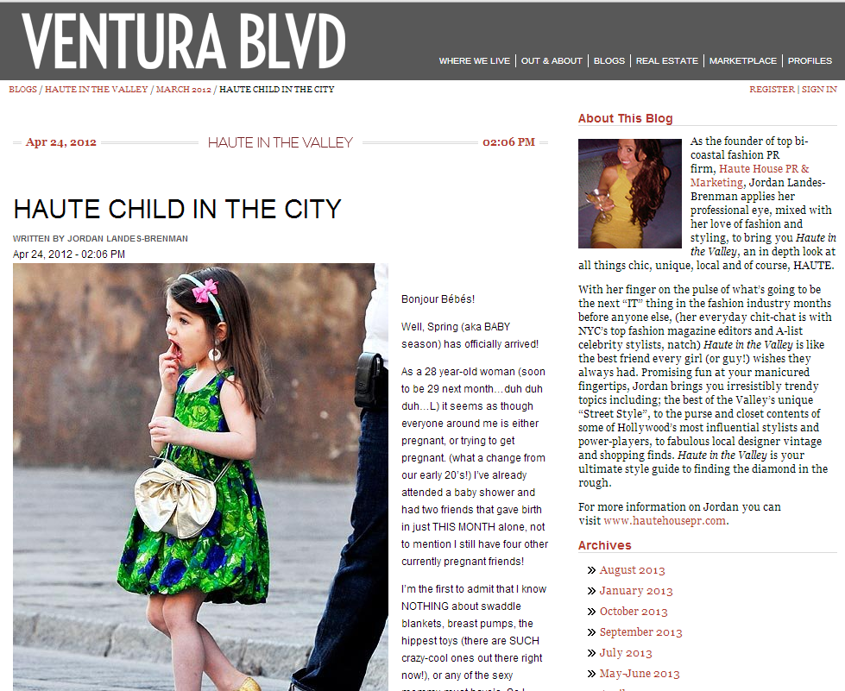
“HAUTE FUSS”-by Jordan Lanes-Brenman, contributor for OurVenturaBlvd.com
http://www.ourventurablvd.com/Blogs/Haute-in-the-Valley/March-2012/HAUTE-Fuss/
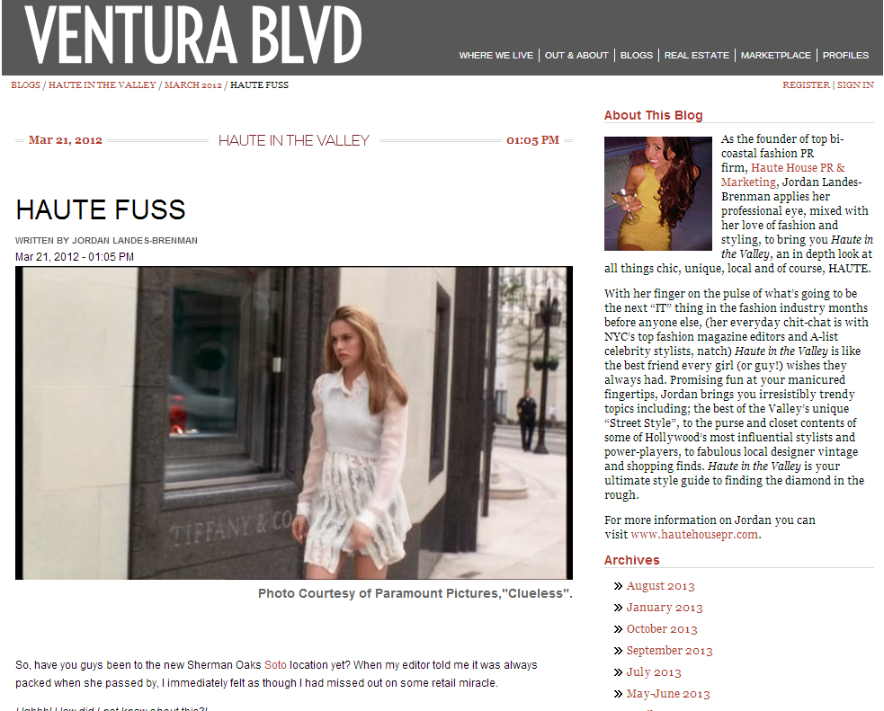

“ANN TAYLOR REMIX GETS RAVE REVIEW”-by Jordan Landes-Brenman, contributor for OurVenturaBlvd.com
http://www.ourventurablvd.com/Blogs/Haute-in-the-Valley/February-2012/NYMWP-Not-Your-Mothers-Work-Pants/
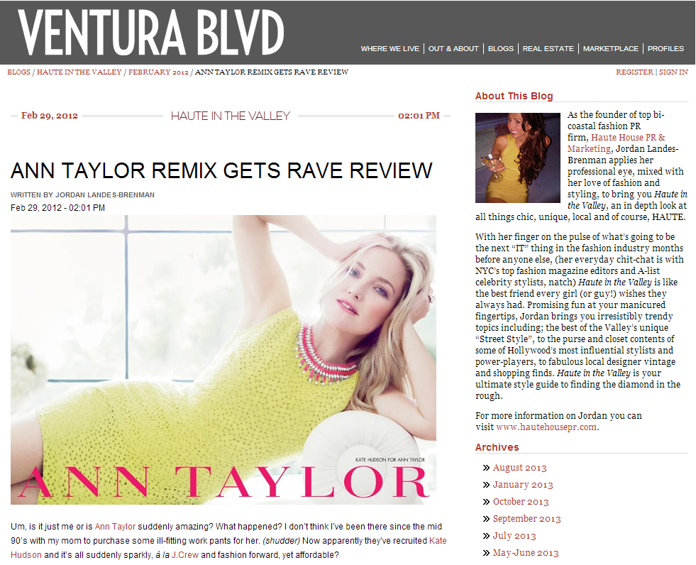
“HAUTE & BOTHERED”-by Jordan Landes-Brenman, contributor for OurVenturaBlvd.com
http://www.ourventurablvd.com/Blogs/Haute-in-the-Valley/February-2012/HAUTE-Bothered/
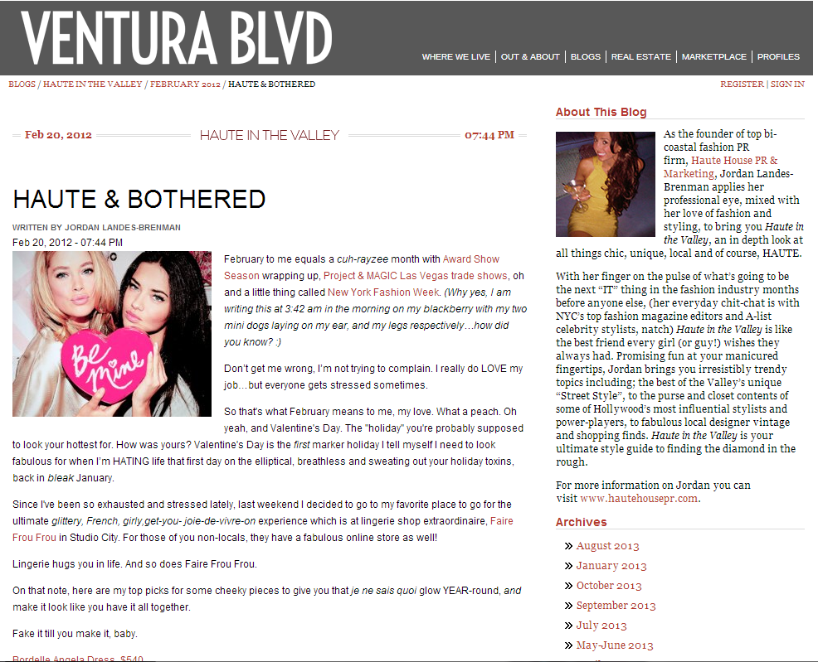

“GET WU'D THIS WEEKEND!”-by Jordan Landes-Brenman, contributor for OurVenturaBlvd.com
http://www.ourventurablvd.com/Blogs/Haute-in-the-Valley/February-2012/Get-WUd-This-Weekend/
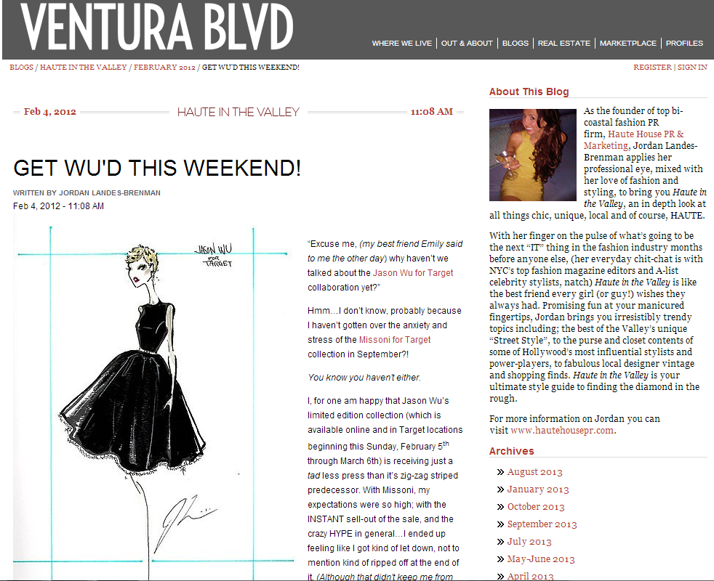

“GOOD HEEL HUNTING”-by Jordan Landes-Brenman, contributor for OurVenturaBlvd.com
http://www.ourventurablvd.com/Blogs/Haute-in-the-Valley/January-2012/Good-Heel-Hunting/
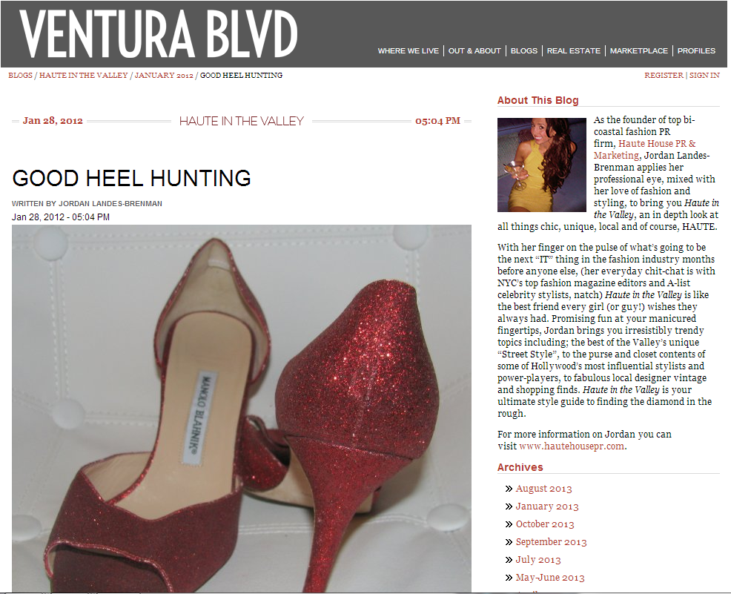

“HAUTE LITTLE HELPERS TO ACHIEVING RED CARPET LOOKS”-by Jordan Landes-Brenman, contributor for OurVenturaBlvd.com
http://www.ourventurablvd.com/Blogs/Haute-in-the-Valley/January-2012/HAUTE-Little-Helpers/
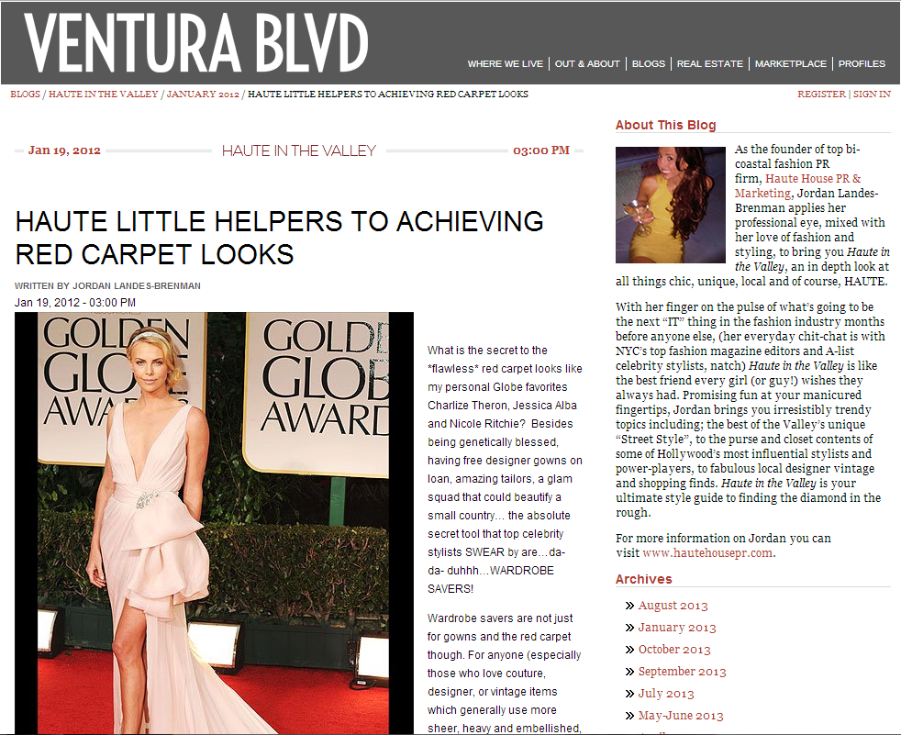
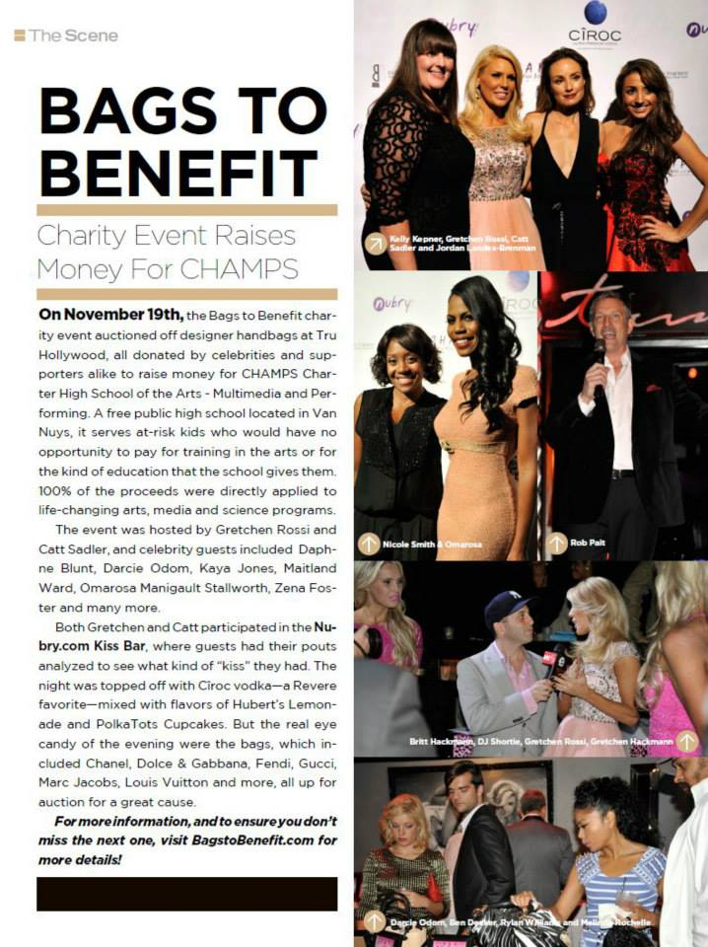


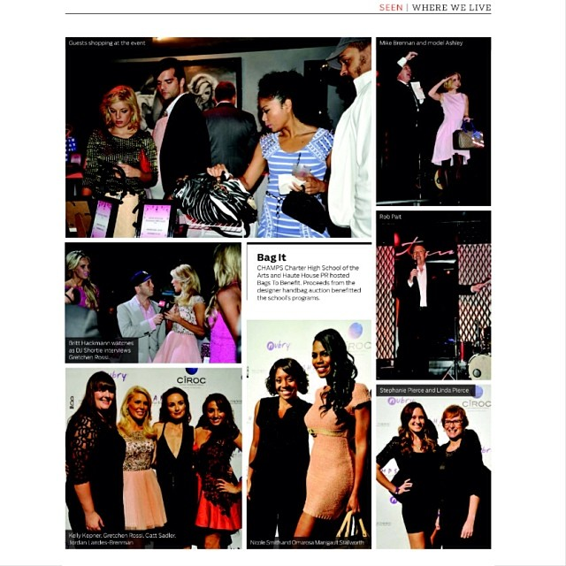
Kelly Kepner, Gretchen Rossi, Catt Sadler, Jordan Landes-Brenman at Bags to Benefit event

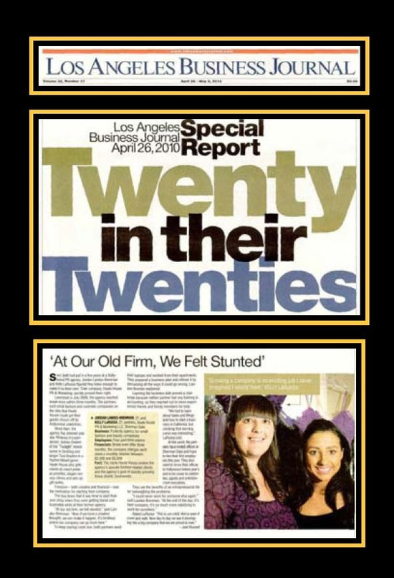
Jordan Landes-Brenman in the Los Angeles Business Journal
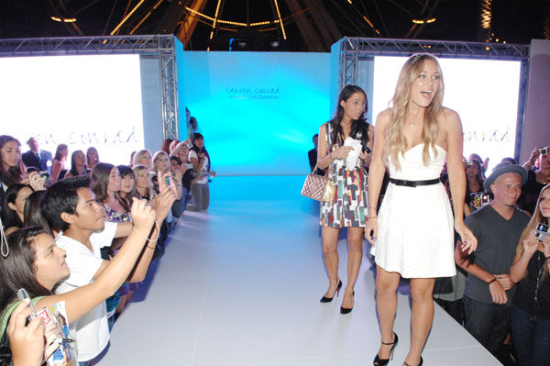
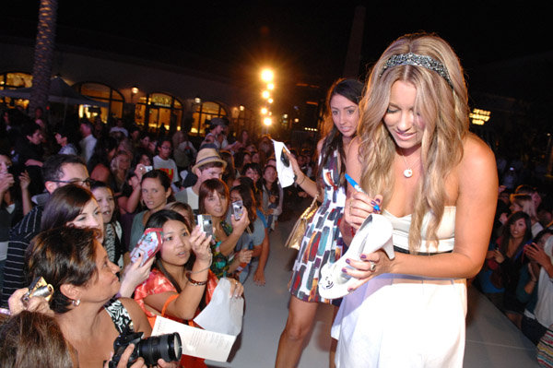

Jordan Landes-Brenman with Lauren Conrad


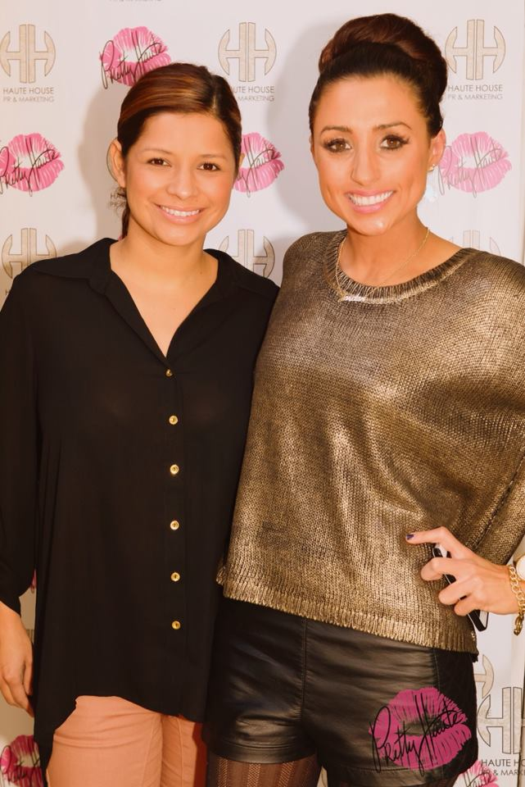

Jordan Landes-Brenman with Andrea Bowman(Top) and Kristina Guerrero (Left)

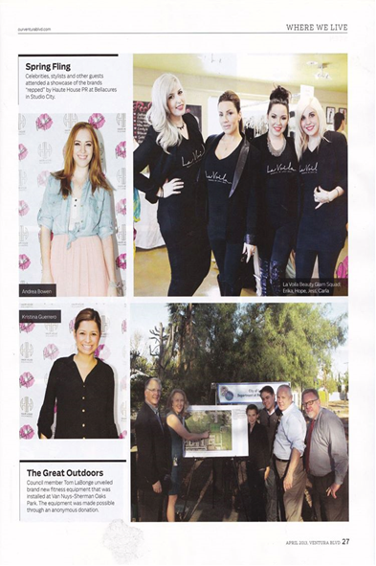
Andrea Bowman and Kristina Gurrero at Haute House PR event

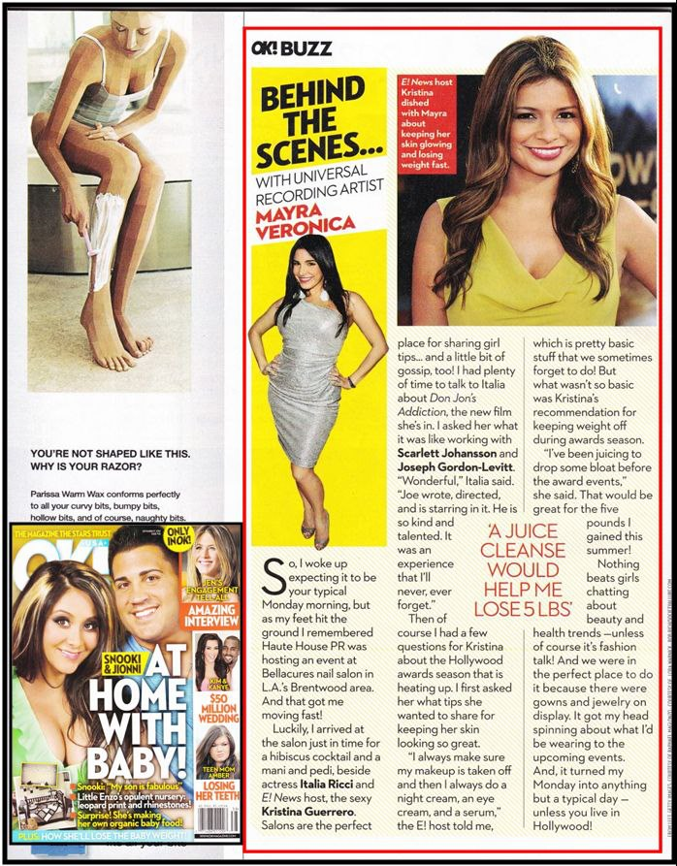
Mayra Veronica at Haute House PR hosted event in OK! Magazine

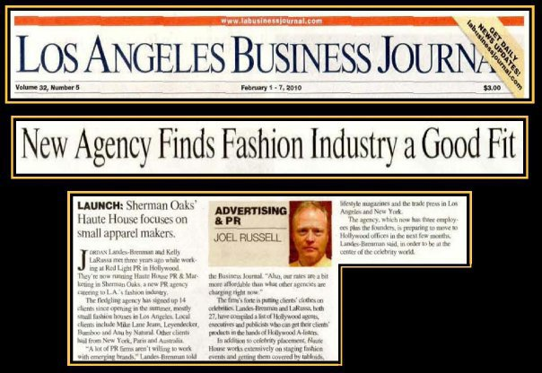

Jordan Landes-Brenman and Haute House PR and Marketing featured in Los Angeles Business Journal

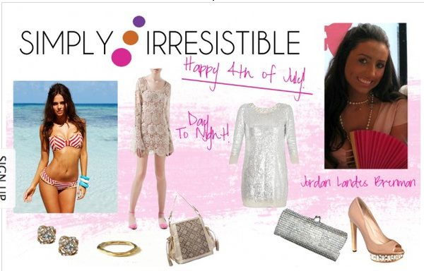
Jordan Landes-Brenman featured on SimplyStylist-June 2012
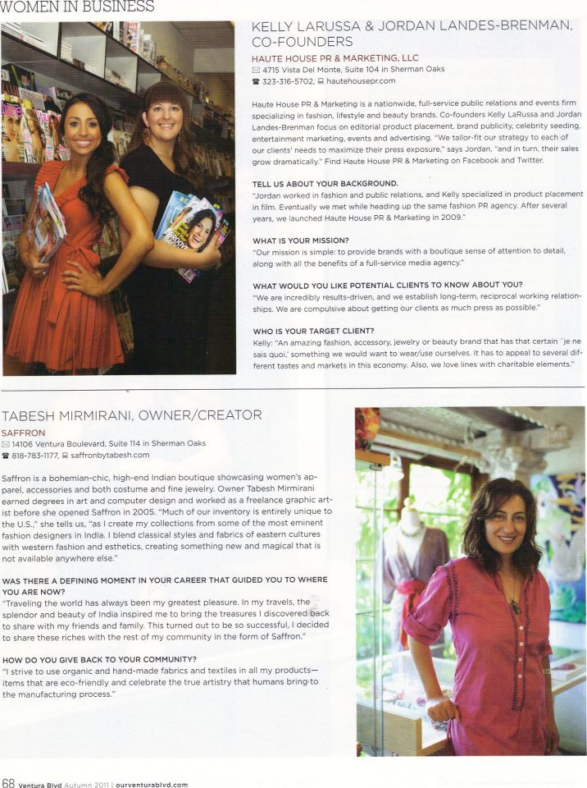
Jordan Landes-Brenman featured in Ventura Blvd Autumn 2011 issue.
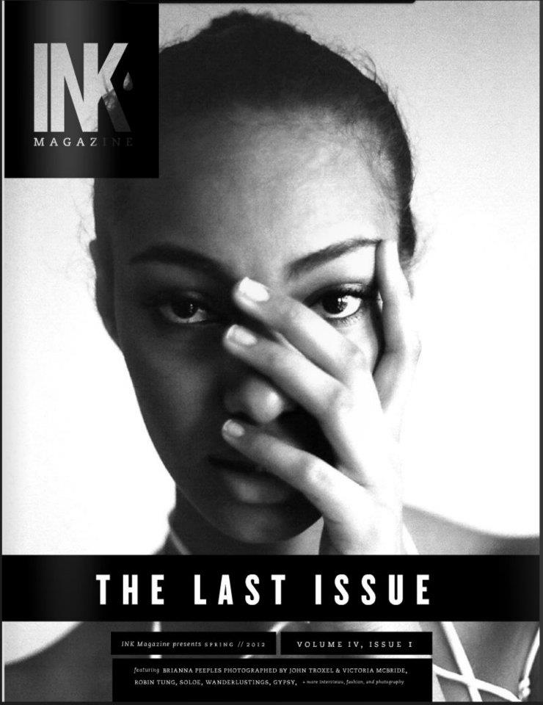

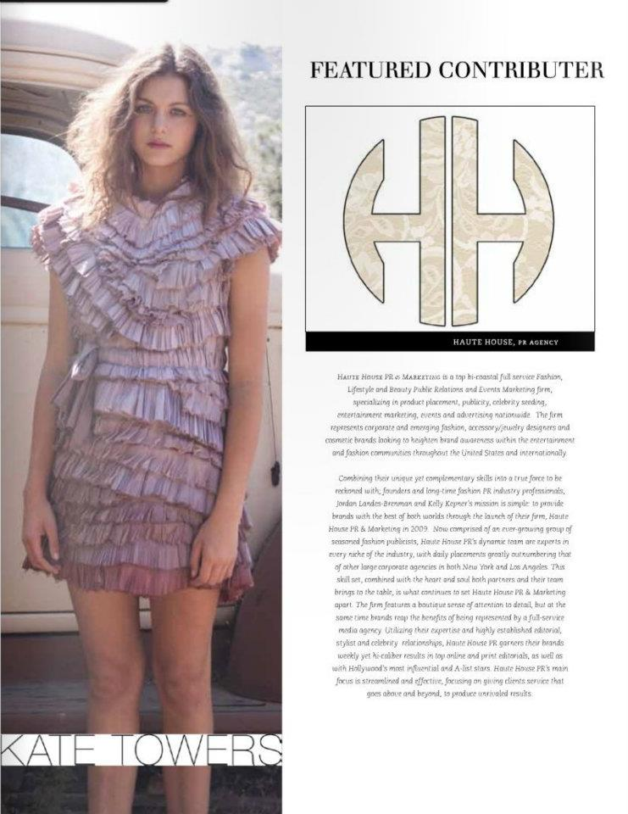Haute House PR featured as contributor for Ink Magazine’s Final Issue in Spring 2012
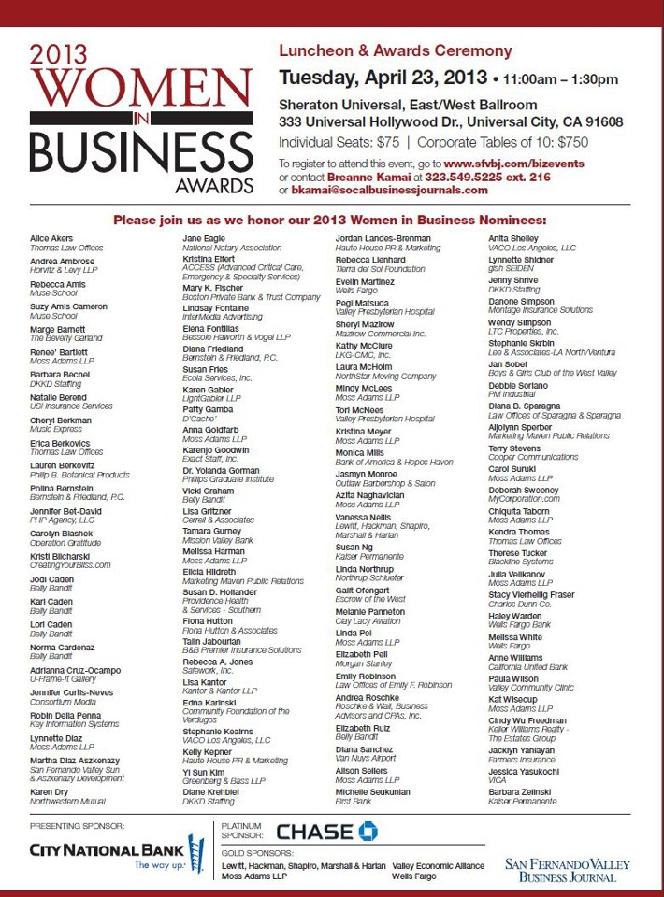 Jordan Landes-Brenman nominated for a 2013 Women in Business Award

Jordan Landes-Brenman featured on invitation for the 2013 Women in Business Award
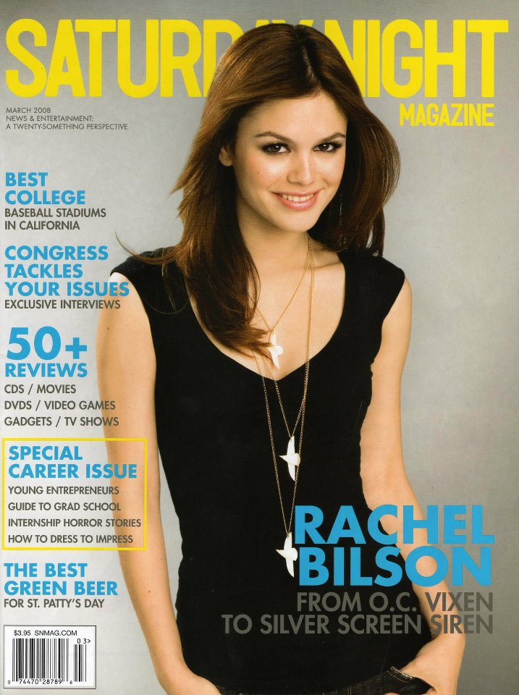
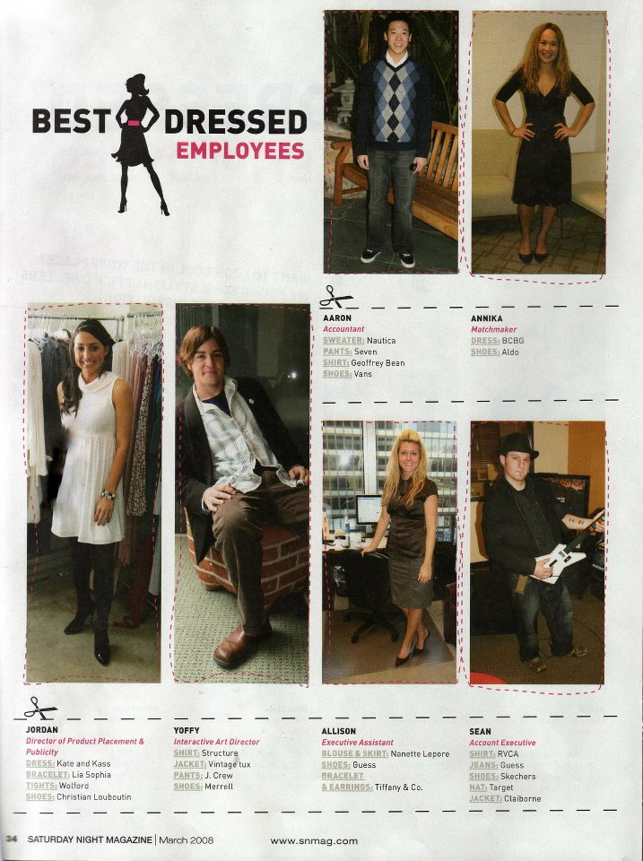

Jordan Landes-Brenman featured in the March 2008 issue of Saturday Night Magazine

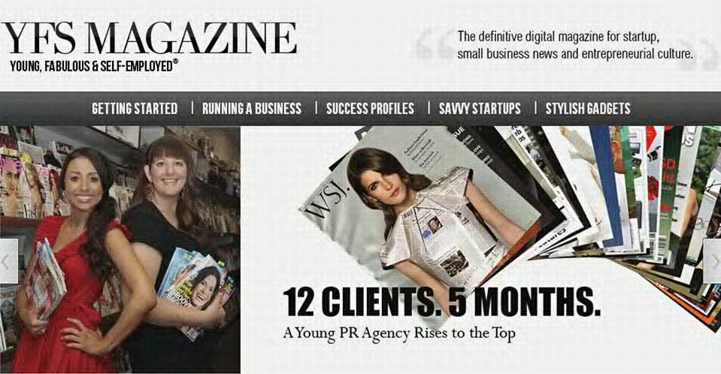
Jordan Landes-Brenman and haute House PR featured in YFS Magazine February 1, 2012

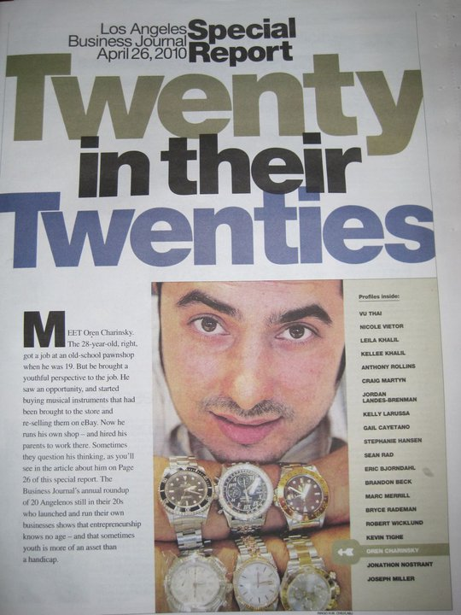

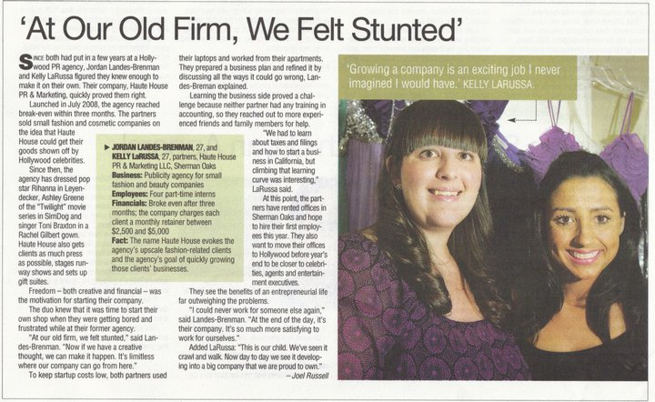
Jordan Landes-Brenman profiled in Los Angeles Business Journal’s “Twenty in their Twenties” Report

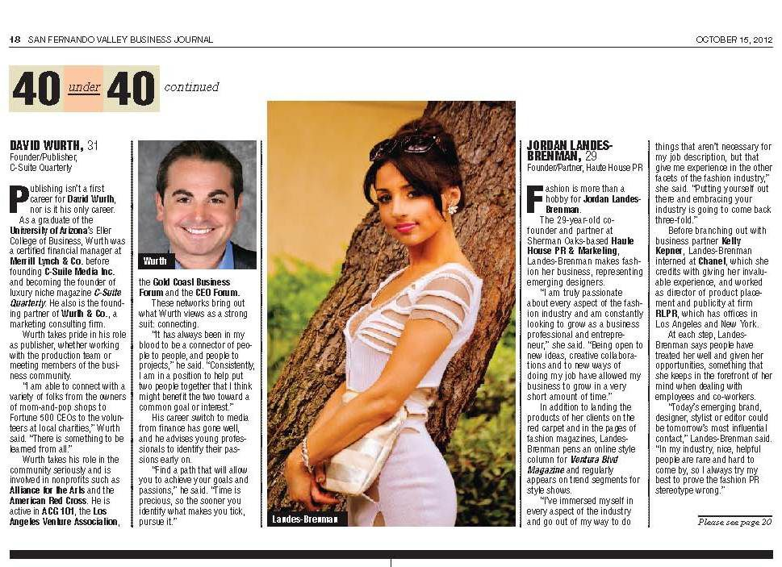
Jordan Landes-Brenman featured in San Fernando Valley Business Journal’s “40 under 40”
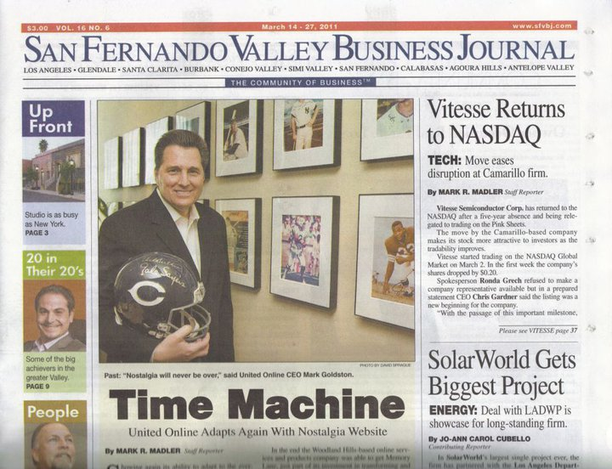

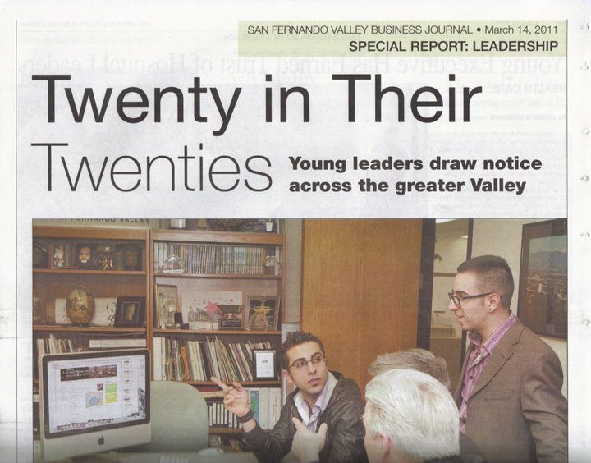

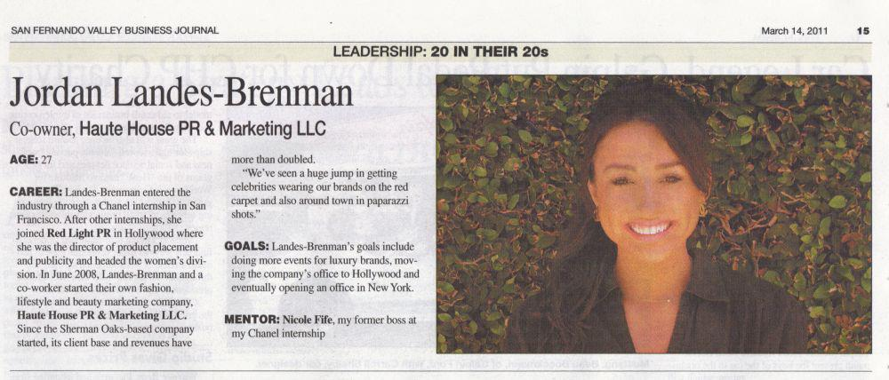
Jordan Landes-Brenman featured in San Fernando Valley Business Journal’s “20 in their 20’s” report.

Jordan Landes-Brenman nominated for the Women Making a Difference 2010 Awards

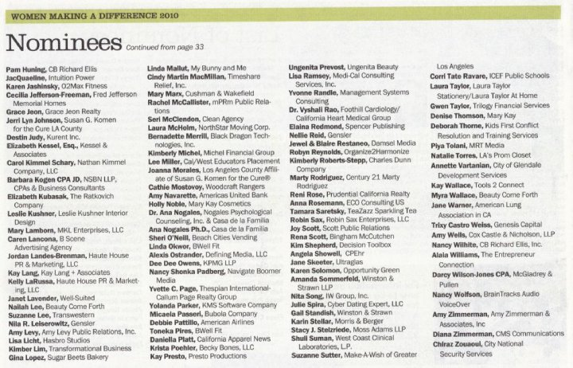

Jordan Landes-Brenman featured in interview with Fashion PR

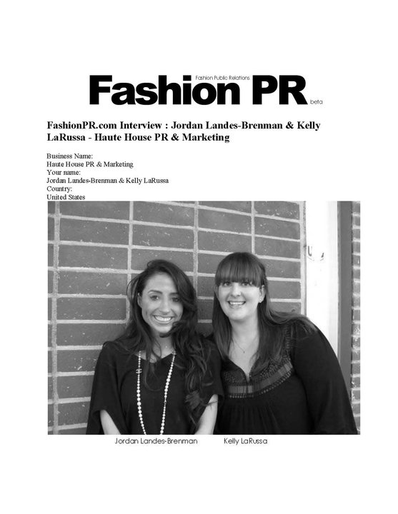

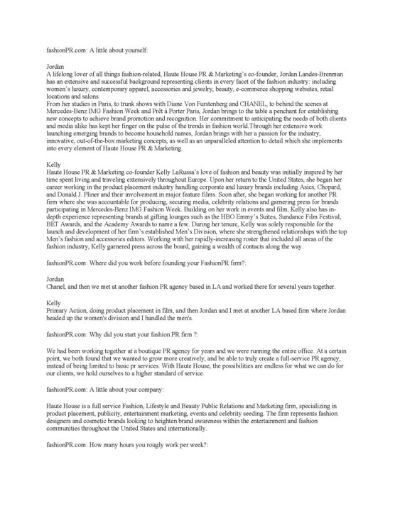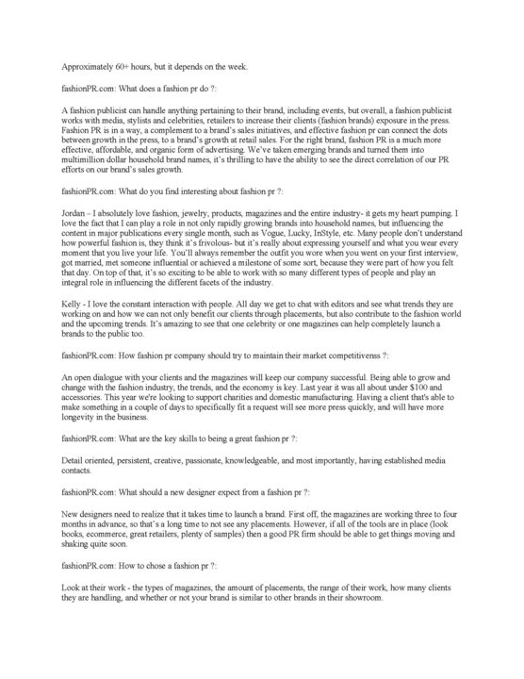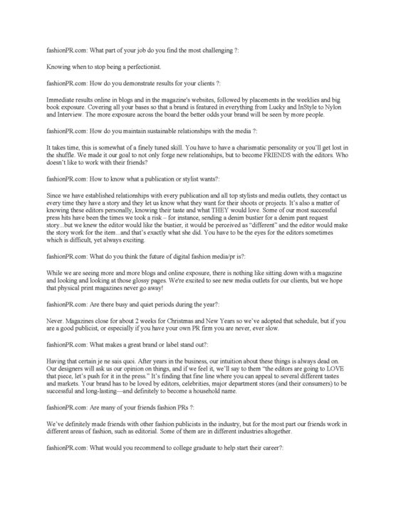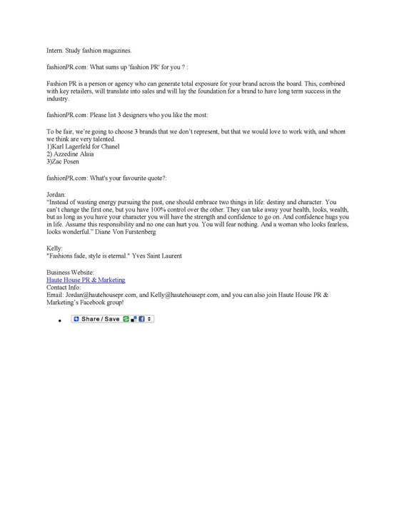 Jordan Landes-Brenman interview with Fashion PR

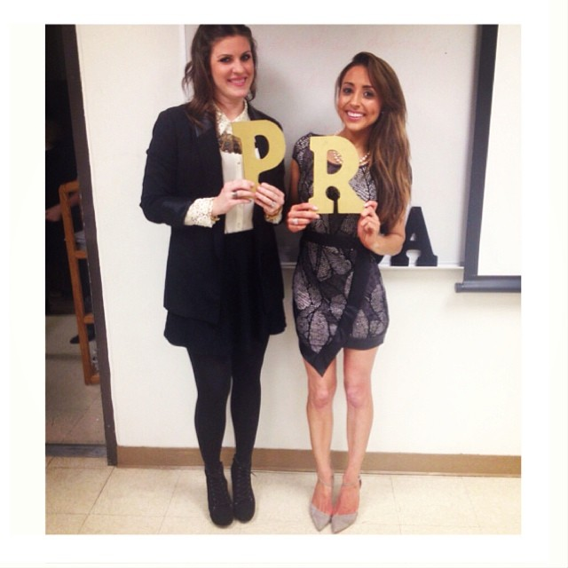
Jordan Landes-Brenman at PRSSA Meet and Greet at Cal State Long Beach

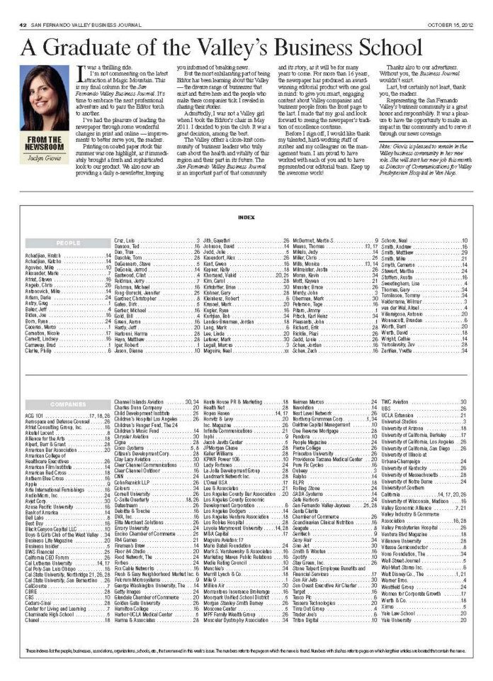
Jordan Landes-Brenman featured as a graduate of Valley’s Business School in San Fernando valley Business Journal October 15, 2012
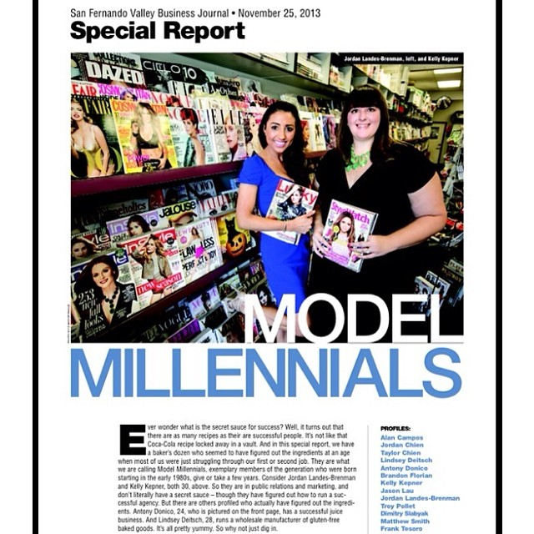

Jordan Landes-Brenman featured in San Fernando Business Journal November 25, 2013

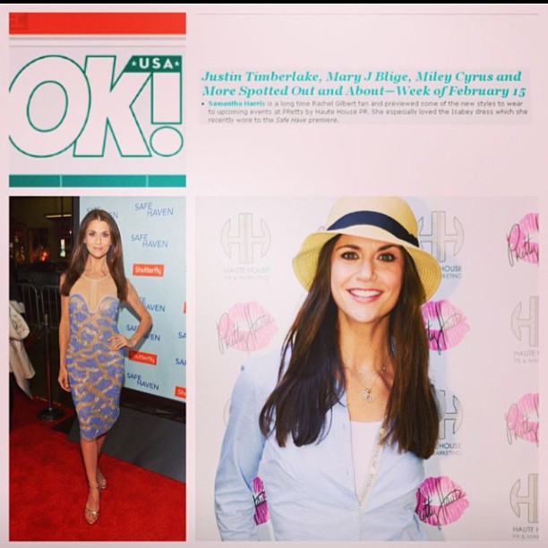

Samantha Harris at Pretty by Haute House PR Event in Ok! Magazine

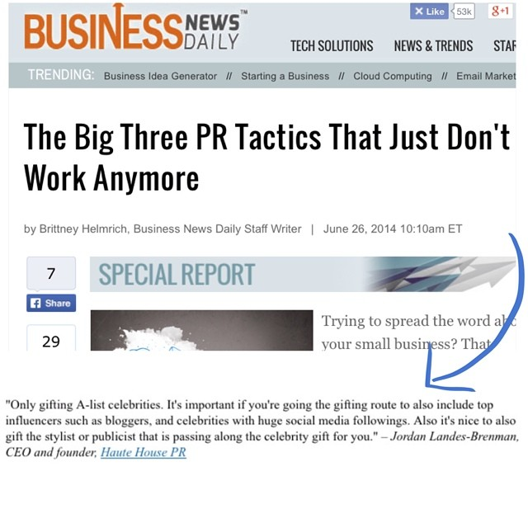
Jordan Landes-Brenman quoted in article “The Big Three PR Tactics That Just Don’t Work Anymore” on Business News Daily

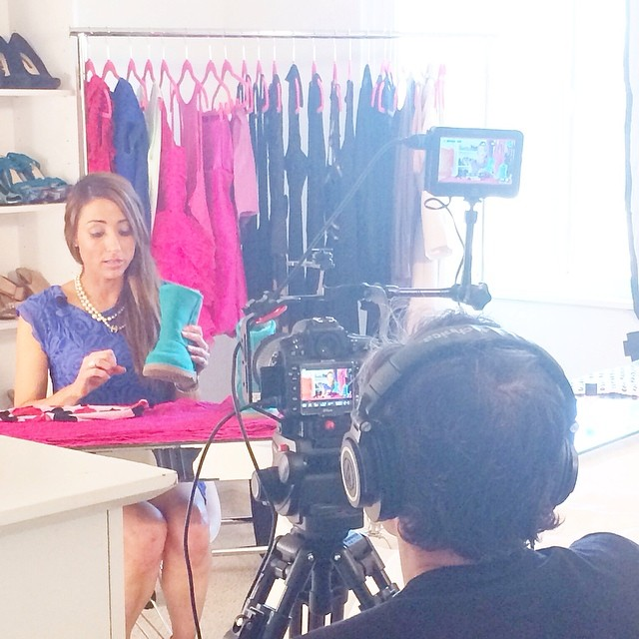

Jordan Landes-Brenman filming for eHow

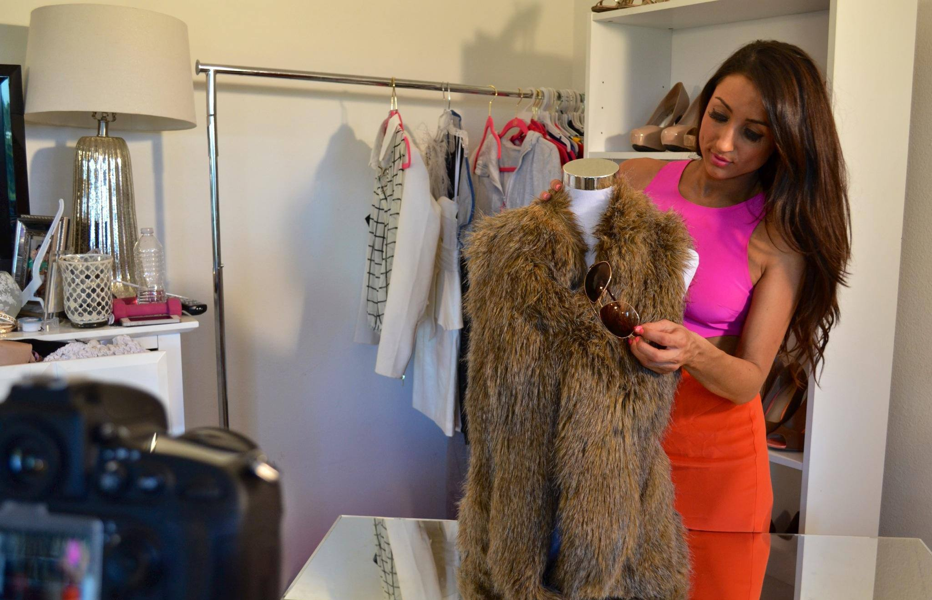
Jordan Lanes-Brenman filming for eHow

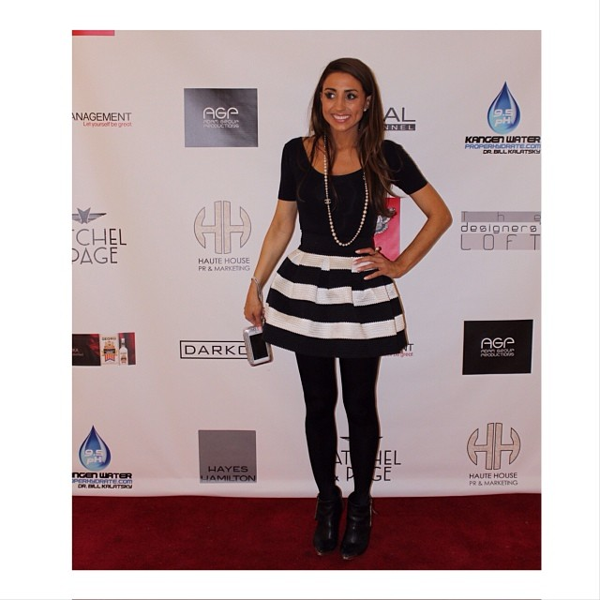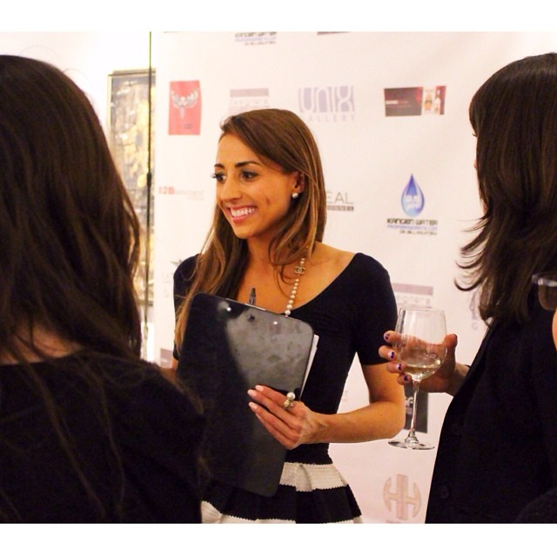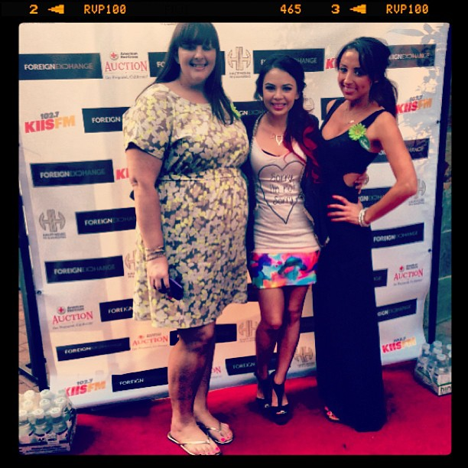
Jordan Landes-Brenman at various Haute House PR Events

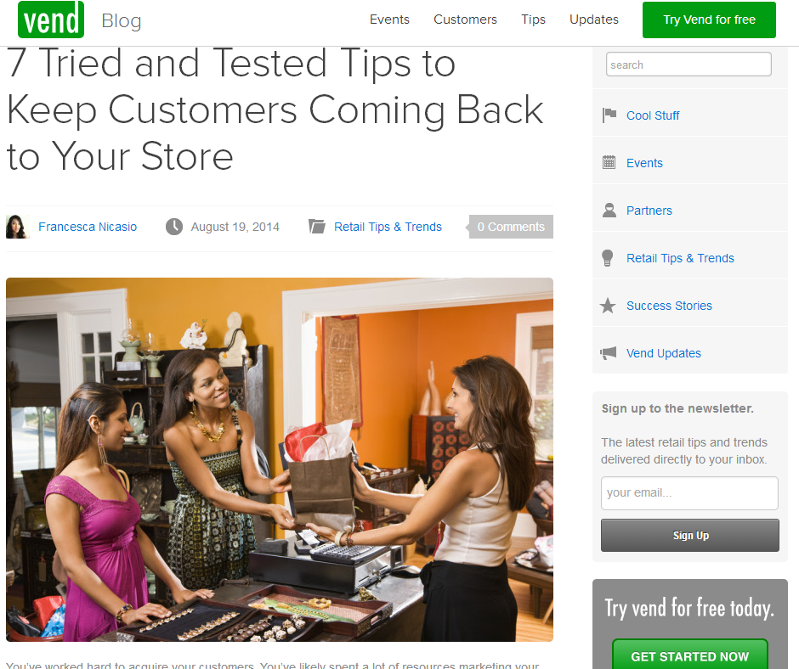
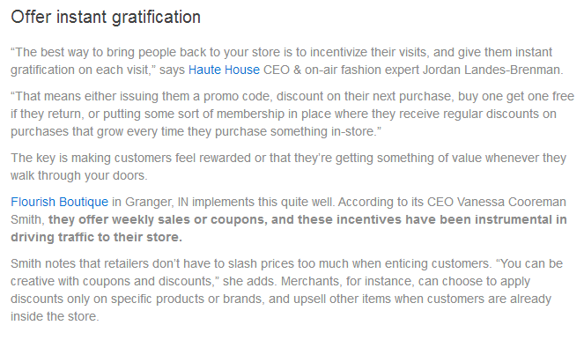
Jordan Landes-Brenman quoted in “7 tried and True Tips to Keep Customers Coming Back to your Store” written by Francesca Nicasio on Vend Blog

